**Assignment-19.2:**

**Convert XML File into Json File Format**

**You can consider below example XML, save it in the hdfs cluster and then to convert into Json File Format. Share the codes used with the screenshot for the same.**

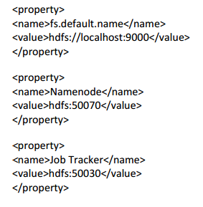

Input File:

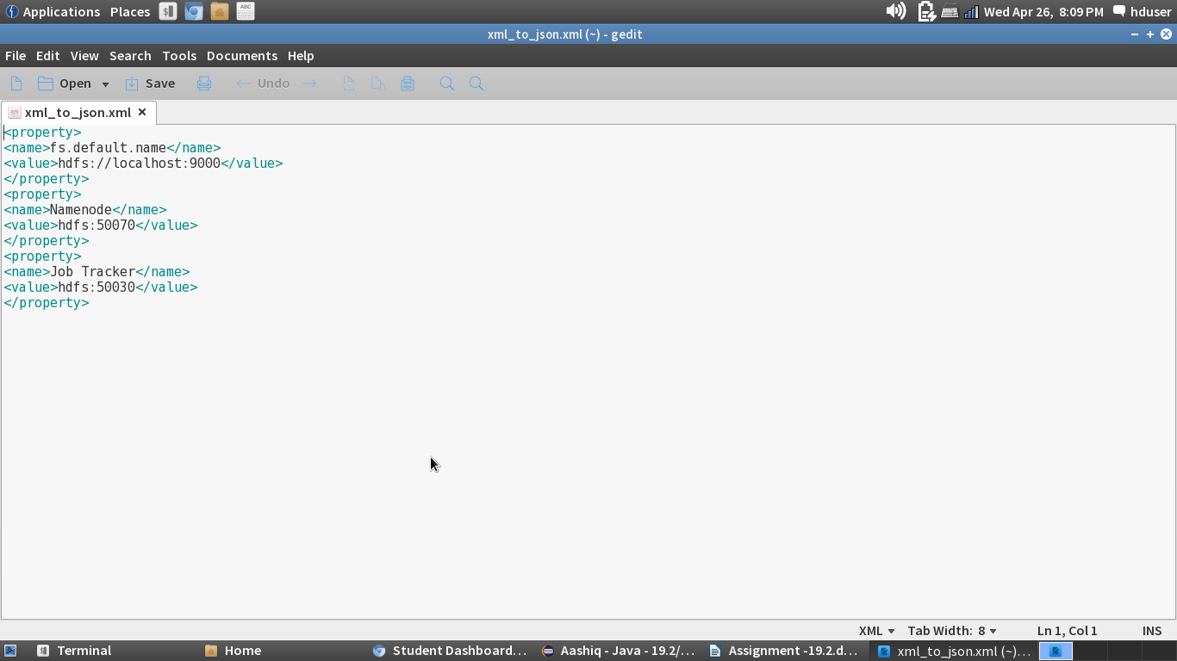

Driver Class:

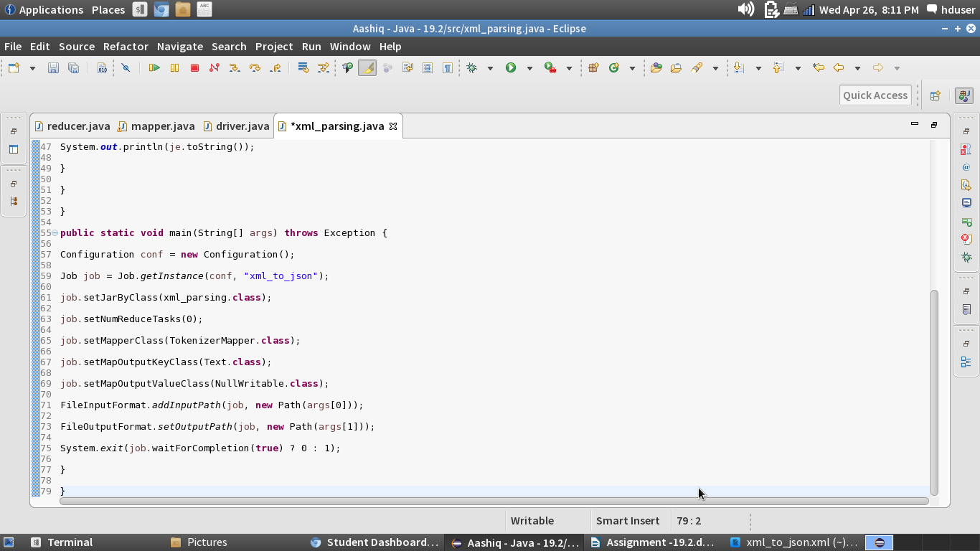

Mapper Class:

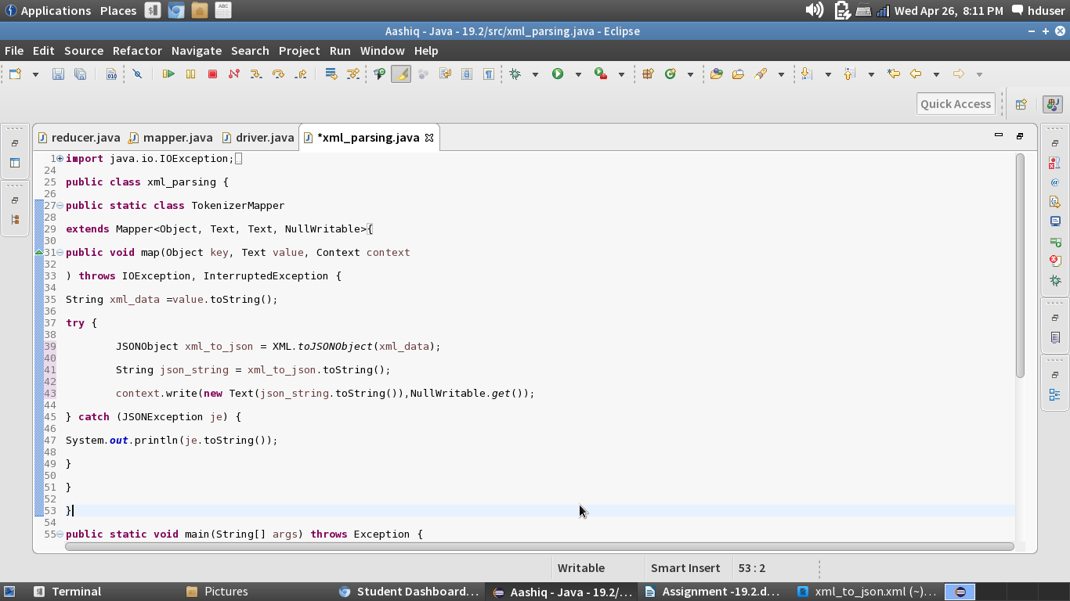

Running the Jar File:

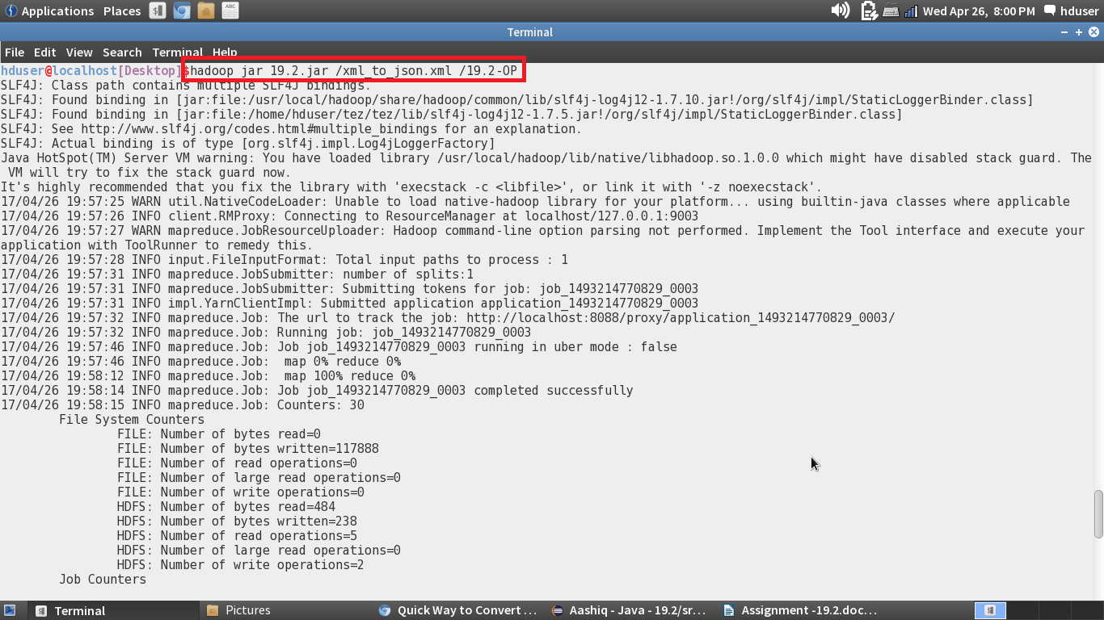

Output File:

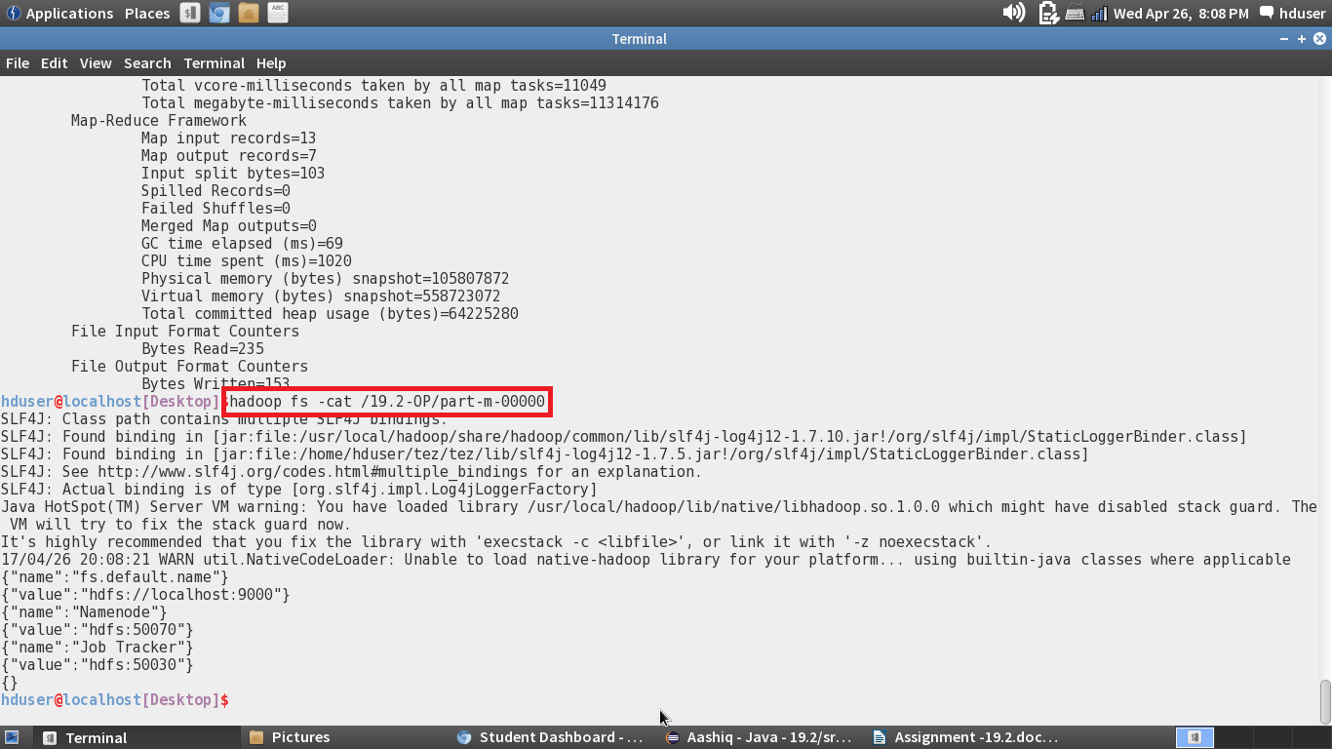

In the above screenshot, we can see that the xml file is converted to Json file format